Briefing Paper
Q3 NABPAC Donor call

- Event: NABPAC Major Donor Call with special guest Representative Ben Ray Luján (NM-3), member Energy and Commerce Committee, Communications and Technology Subcommittee. Chairman, Democratic Congressional Campaign Committee

- Location: Chairman’s Conference room or Dial-in
Host Dial-in Participant Dial-in
888-505-4375 888-438-5524
Conf ID: 5987337
*reference NABPAC conference call

3. Contact: Jennifer Stong Flemming
(202) 631-2519

- Time/Date: Wednesday, July 8
2:00 pm EST
*the host must dial-in 10-15 minutes prior

- Staff: Senator Gordon Smith, Mike Mullen, Jennifer Flemming, Alex Grant
- Timeline:
1:50 p.m. Jennifer dials into host line
2:00 p.m. Moderator starts the call and introduces Senator Gordon Smith
GHS gives NAB overview and introduces Rep Luján
2:05 p.m. Rep Luján gives his remarks
2:20 p.m Rep Luján completes comments and opens it up for Q&A
2:35 p.m. GHS thanks our guests and all participants. Call ends

- Background: We host quarterly conference calls with our major donors ($500+) as part of their member benefits package. Please thank these major donors for their support, and update them on the political landscape, as well as current broadcast issues.

- Talking points:
- These are top three issues NAB is facing in 2015:
- Performance tax / Copyright review
- Retransmission consent /Comm Act Update
- Advertising deductibility
- Emphasize how their support of NABPAC helps us face these issues & have a voice
- NABPAC’s 2015 goal is $1.1M

- Attendees
First Name | Last Name | Title | Company
Dustin | Hall | Sr. Mobile Products Manager | Quincy
Robert | Prather | President/CEO | HEARTLAND MEDIA, LLC
Eric | Bradley | GM | NPG
Bob | Houghton | President | Georgia Association of Broadcasters
Rick | Williams | General Manager | WLOX-TV
Bill | McElveen | Executive Vice President | Alpha Media
Debbie | Bush | VP/GM | WXIX
Joe | Sciortino | VP/GM | WDAM/Raycom
Francisco | Montero | Managing Partner | Fletcher Heald and Hildreth
Rebecca | Hanson | Senior Vice President, Strategy and Policy | Sinclair Broadcast Group
Tim | Busch | COO | Nexstar Broadcasting Group
Tariq | Islam | Director, Advanced Technology | NAB
John | Feore | Partner | Cooley
Mark | Allen | President and CEO | WSAB
Beth | Neuhoff | President/CEO | Neuhoff Communications
Jim | Wilcox | V.P. / GM | WALB
Mark | Prak | Partner | Brooks Pierce
Ed | Henson | President | Henson Media, Inc.
Gary | McNair | Vice President and General Manager | WECT / Raycom Media
Patricia | Smullin | Owner / President | California Oregon Broadcasting Inc
Francisco | Montero | Managing Partner | Fletcher Heald and Hildreth
John | Fink | Vice President/General Manager | KFVE- TV
Billy | McDowell | VP Research | Raycom Media
John | Garziglia | Partner | Womble Carlyle
Erik | Schrader | General Manager | KSN
Tim | Ingram | VP/GM | Raycom
Mike | Tarter | President/CEO | Forcht Broadcasting
Brad | Streit | Sr VP | Raycom Media
Holly | Steuart | Vice President and General Manager | WTVM - Raycom
Frank | Jazzo | Co-Managing Member | Fletcher, Heald and Hildreth, PLC
Eric | Duncan | V.P. General Manager | WSFA TV [Raycom]
Bill | Harland | Vice President of Marketing | Electronics Research, Inc.
Tracey | Rogers | Vice President/General Manager | WMC-TV
Ted | Fortenberry | VP and GM | WLBT / Raycom
Jay | Howell | Vice President, Broadcast Markets | Media General
Gregg | Skall | Partner | Womble Carlyle Sandridge and Rice, LLP
Frank | Washington | CEO | Crossings TV
Pat | Stacey | VP / General Manager | KLTV-TV
Ann | Bobeck | Sr VP and Deputy General Counsel | NAB
Sandy | Breland | Group Vice President | Raycom Media
Ken | Freedman | VP/General Manager | WCMH

- Bio

Biography
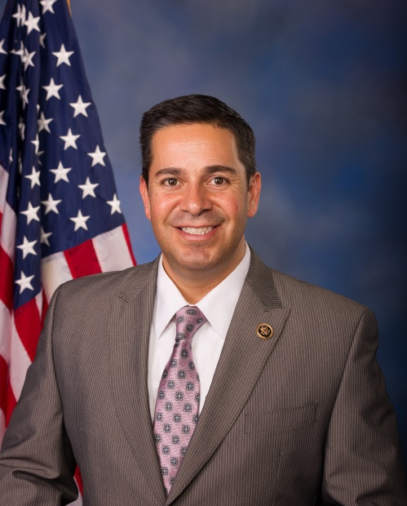
Born and raised in New Mexico, Rep. Ben Ray Luján grew up in Nambe, a small farming community north of Santa Fe bordered by the pueblos of Nambe and Pojoaque. There he learned the time-honored traditions and values of New Mexico.
Since he was sworn into Congress, job creation, reforming health insurance, building a clean energy economy, and standing up for consumers have been key priorities for Rep. Luján.
He has stood up for New Mexicans who are struggling in these difficult economic times by voting to provide tax cuts for families and small businesses, working to reform our broken health insurance system, and fighting to reform Wall Street. He has worked for the people of New Mexico's 3rd Congressional District, passing legislation that invests in scientific research at New Mexico’s national laboratories, fighting for Tribal Colleges and Universities and Hispanic Serving Institutions in the America COMPETES Act, and advocating for tribal communities by improving infrastructure, education, and health care.
Rep. Luján represents his diverse district by participating in a variety of Caucuses including the Congressional Hispanic Caucus, the Native American Caucus, and the Natural Gas Caucus.
Rep. Luján sits on the Energy and Commerce Committee, which enables him to serve the many needs of the district which spans from San Juan County in the Northwest to Roosevelt County in the Southeast – and the treasured lands in between.
As a member of Communications and Technology Subcommittee, Rep. Luján is working to expand broadband access in rural communities and see that new opportunities are created through increased access to the latest technological advances. From his position on the Health Subcommittee, Luján is focusing on increased access to health care, reducing health disparities, and addressing drug abuse that has impacted too many families in New Mexico.
At the beginning of the 112th Congress, Rep. Luján, together with co-chair Frank Wolf of Virginia, founded the bipartisan Technology Transfer Caucus to bring together members who share the goal of strengthening our economy by helping move technological innovations that are occurring at New Mexico’s national labs and universities into the marketplace. Luján will also serve as a co-chair of the bipartisan National Labs Caucus, which will raise awareness about the importance of the national labs to the long-term economic vitality and security of the nation.
At the beginning of the 113th Congress, Rep. Luján was appointed to the House Democratic Leadership as a Chief Deputy Whip. In this position, he is promoting the Democratic agenda to create jobs and build a brighter future for all Americans. At the end of 2014, Luján was named Chair of the Democratic Congressional Campaign Committee, and will serve in this role during the 114th Congress.
Prior to his election to Congress, Rep. Luján served as the Chairman of the New Mexico Public Regulation Commission. As a Commissioner, Rep. Luján worked with his colleagues to develop a renewable portfolio standard to increase renewable energy production by New Mexico utilities to 20 percent of their total production by 2020 and to diversify utilities’ renewable portfolios to include solar energy. On behalf of the state of New Mexico, Rep. Luján joined his fellow Commissioners from California, Oregon, and Washington to sign onto the Joint Action Framework on Climate Change to create regional solutions to climate change.
With the New Mexico Public Regulation Commission, Rep. Luján advocated for first responders. He worked with firefighters, the state legislature, and other officials to overhaul the New Mexico Fire Fund so that all distributions from the fund would go to improving fire services in New Mexico.
Rep. Luján also worked to improve health care as a member of the New Mexico Public Regulation Commission by investigating the denial practices of the health insurance industry. The investigation led to the development of legislation that expanded access to insurance and closed loopholes the industry had been using to unfairly deny medical claims and void policies. Prior to that, he served as New Mexico Cultural Affairs Department’s director of administrative services and chief financial officer.
Rep. Luján earned his Bachelor's degree from New Mexico Highlands University in Business Administration.

