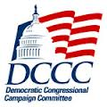
OVERVIEW
The margin in the 65 closest races in 2012 was roughly 1 million voters. We know that in 2014 drop-off voters will be critical to making significant gains in taking back the House of Representatives for Democrats. The
“1 Million Votes for 2014” Commit to Vote Program is designed to target those drop-off voters.

IMPACT
There is scientific evidence that shows the importance of reminding a voter of their commitment to vote in the final two weeks before they vote. This reminder is equivalent to adding a voter contact on the door. The program is simple but will make a huge impact on turnout, especially with early voter contact efforts. The collection of commits will be prioritized by door-to-door canvassing efforts, but will also include collection from voter contact phone calls and targeted digital outreach. Voters who commit will be reminded of their commitment by receiving a 1 Million Votes Commit Card in the mail or online prior to Election Day.

HOW YOU CAN HELP
All Members of Congress can have a huge impact on the success of the “1 Million Votes for 2014” Campaign. We want your help – you can participate in several ways:

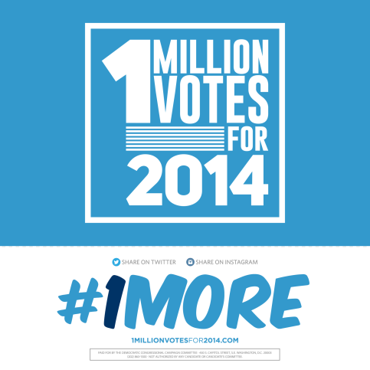
- Staff Support: Members are encouraged to allow staff to support the ground operations to collect these commits to vote. Depending on experience level, deployed staff will play various roles within the campaign’s field operation. Deployed staff will knock doors, make calls, reach out to key turnout targeted constituencies, organize the commit card program and support various field needs to engage turnout voters. Note: While ethics rules permit official staff to volunteer their time, they must do so on their own time and without using official resources, and they may not be compelled to volunteer.

- Canvass Trips: Members, their staff and district volunteers are encouraged to plan trips to targeted districts and participate in voter turnout canvasses throughout the campaign season. These efforts will be CRITICAL in all targeted districts. A small group of 20 people travelling into the district can easily knock on 1,000+ doors and collect more than 300 invaluable commits to vote.

- Phone Bank(s): Organized phone banks by Members are another great way to engage sporadic and new voters in targeted districts. These phone banks will be coordinated to target a specific district and volunteers would collect commits to vote from targeted voters via phone. These phone banks can be organized in district or held in DC at the Democratic National Committee Headquarters.

- Social Media: You can support the 1Million Votes program through your campaign or personal (but not official) social media outlets. Take a picture with the commitment card and post it on Facebook and Twitter. Make sure to tag it: #1More.
Paid for by the Democratic Congressional Campaign Committee, www.dccc.org, and not authorized by any candidate or candidate's committee.

